Install ec agent on Ubuntu 16

If you want to install the ec-agent on the openstack with Ubuntu 16.04

1. Create instance on the openstack

The only thing you will need to care is the Security Groups

You need to choose these

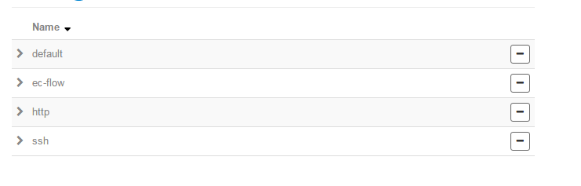

1. Login the instance
2. Throw the wget to get the newest package from

[https://nexus-proxy.in.hpecorp.net/nexus/content/groups/HPINT-public-M2/com/hp/ec/bits/flow/linux/agent/ElectricFlowAgent-x64/](https://nexus-proxy.in.hpecorp.net/nexus/content/groups/HPINT-public-M2/com/hp/ec/bits/flow/linux/agent/ElectricFlowAgent-x64/6.5.0/)

find the latest package

use wget like this

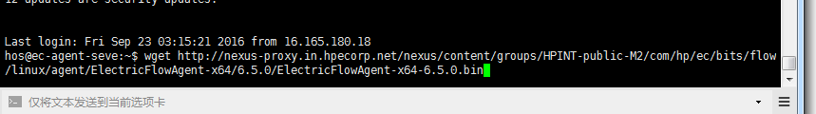

1. Install EC agent

dpkg --add-architecture i386

apt-get update

apt-get install libc6:i386 libstdc++6:i386



then chose like this

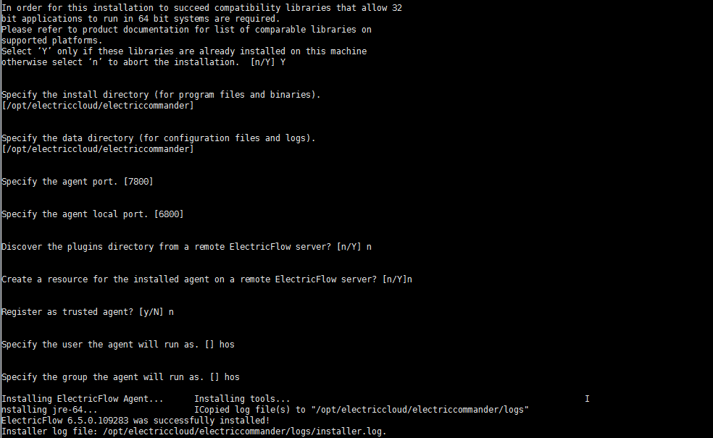

1. Create resource on the page of EC

